
Lab 05

Submitted to: Mr. Khurram Iqbal
Submitted by: Arafat Khan
Registration No: FA25-BDS-013
Class/ Section: BDS-1A
Submission date: 29/09/2025

Department of Computer Science

Lab Task 01 (Code)
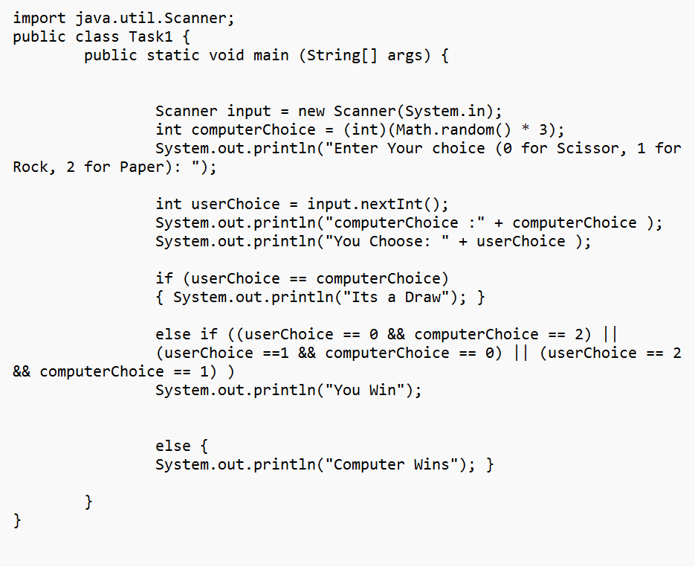

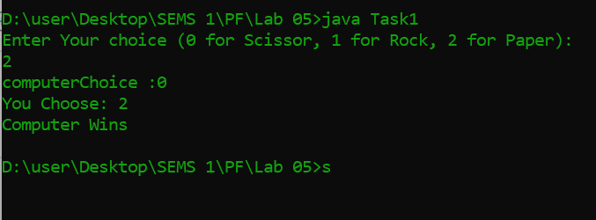
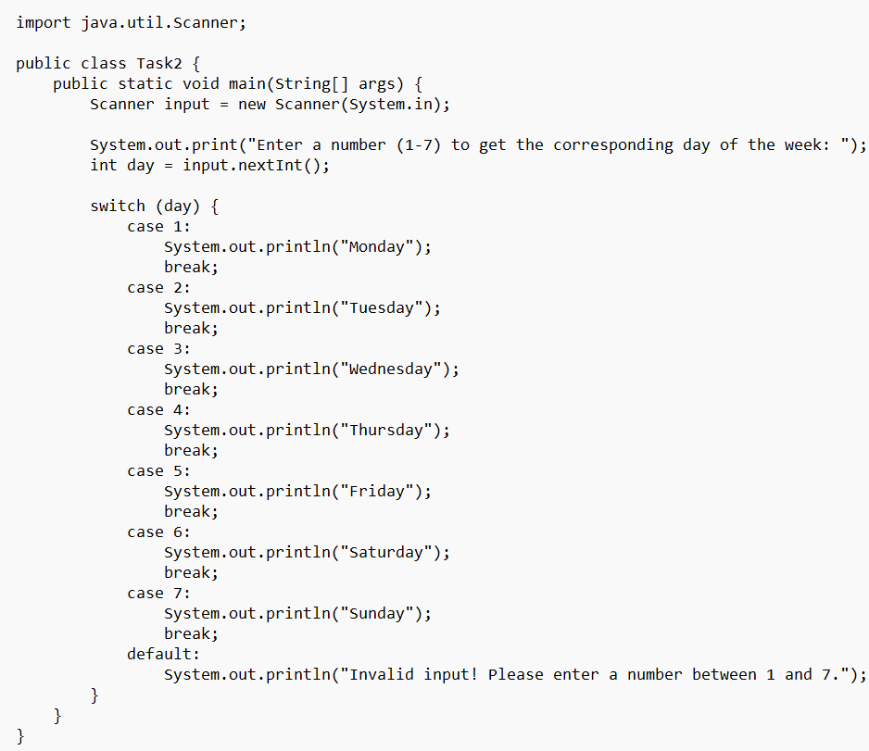
Lab Task 02 (Code)
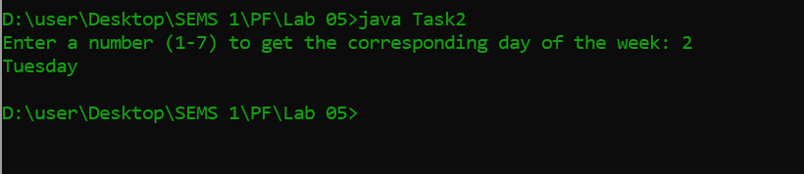

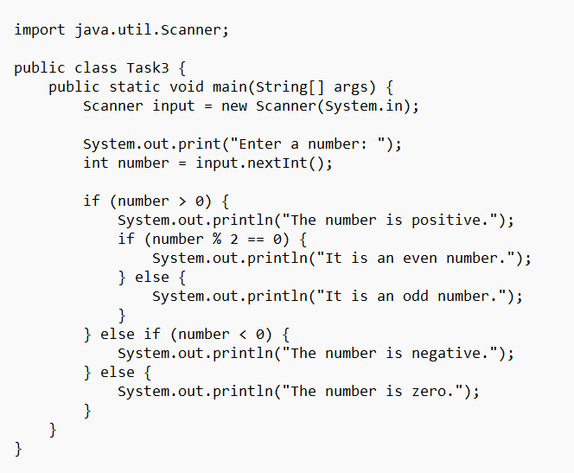
Lab Task 03 (Code)

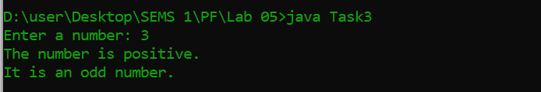

Lab Task 04 (Code)
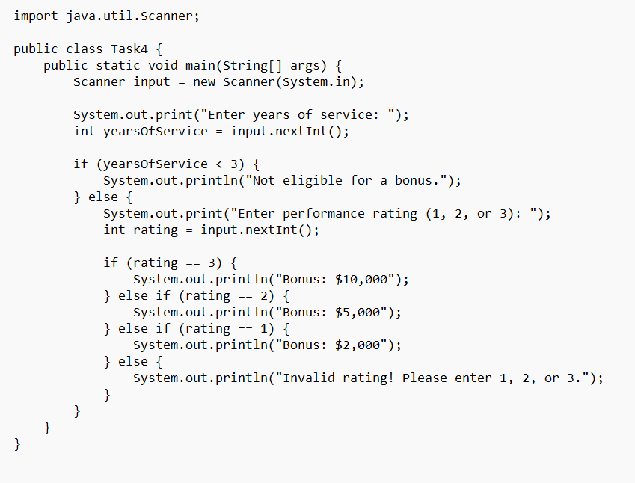
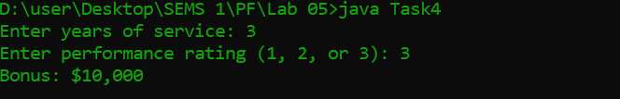

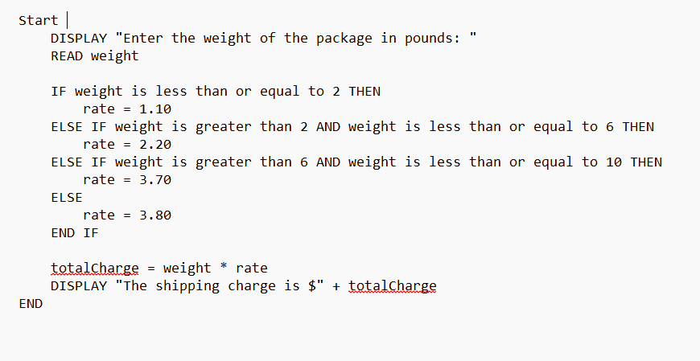
Lab Task 05 (pseudoCode)
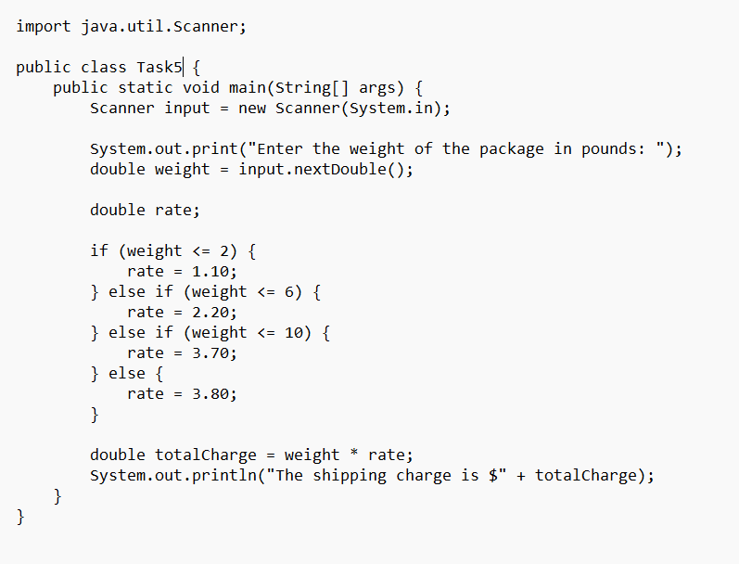
Lab Task 05 (Code)

Lab Task 05 (Output)
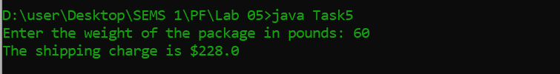
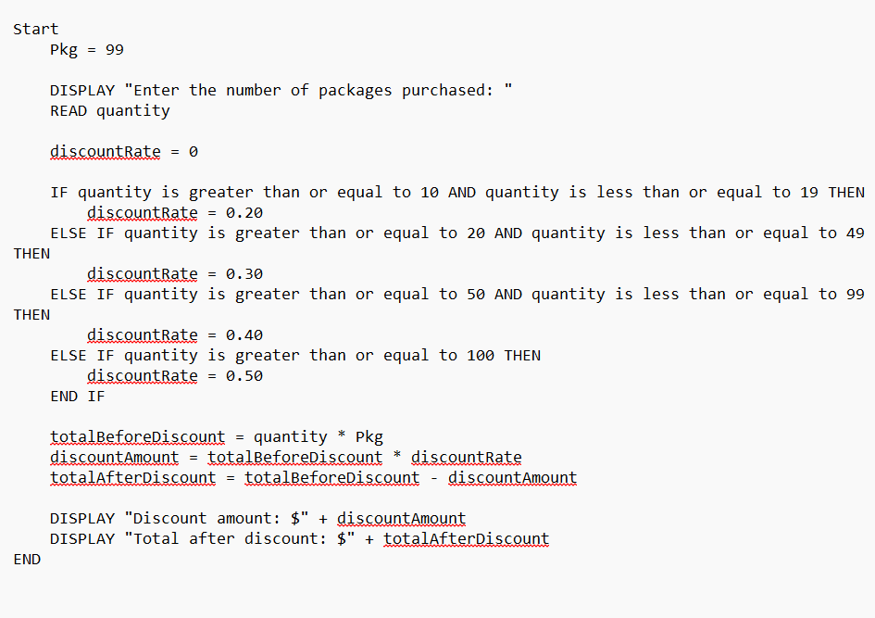
Lab Task 06 (pseudoCode)

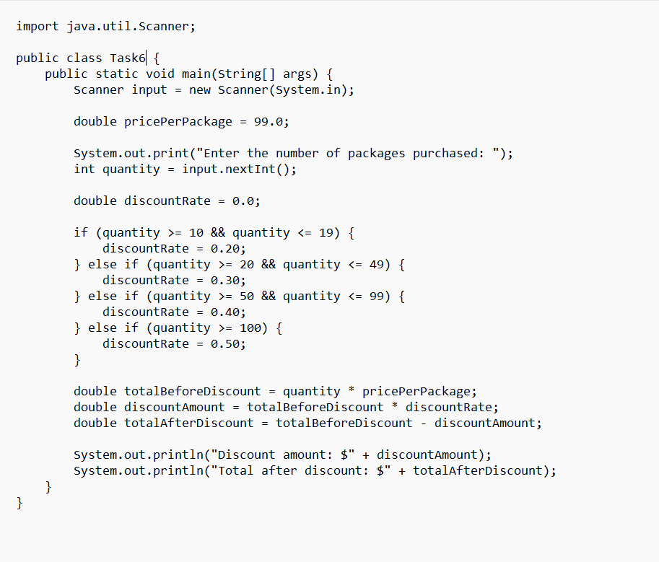
Lab Task 06 (Code)
Lab Task 06 (Output)
